The role of religious leader to intercept child marriage is crucial-Step toward prosperity

In suddhodhan Rural Municipaliy Child Marriage was taken as a traditional culture. The community people thought Marriage of their child in small age helps to get self satisfaction and a place in heaven. Similarly they have taken a girl child as burden in their family and also think that they have to give more dwary if the daughter child was older. If they have done a marriage of daughter child in small age they can finish the marriage in small dwary which leads to stop the education of the adolescent girls in middle of the school.
To fight and to minimize such types of problems from the community KSSC-Nepal under Amplify change program was launched. The main aim of this project is to ensure sexual and reproductive rights of adolescents and end of child marriage. To achieve this goals and target we have oriented different stakeholders like: Dharma guru, Pandit, Community leaders, Sokhas, Maulamas, Adolescent network group, Youth club, Child club and governmental Stakeholder and Health facility representative on child rights and Sexual and reproductive rights. All the participant have written committed to end child marriage and dwary system from their community and also committed to provide awareness on the community level on child rights, child marriage and sexual and reproductive rights.
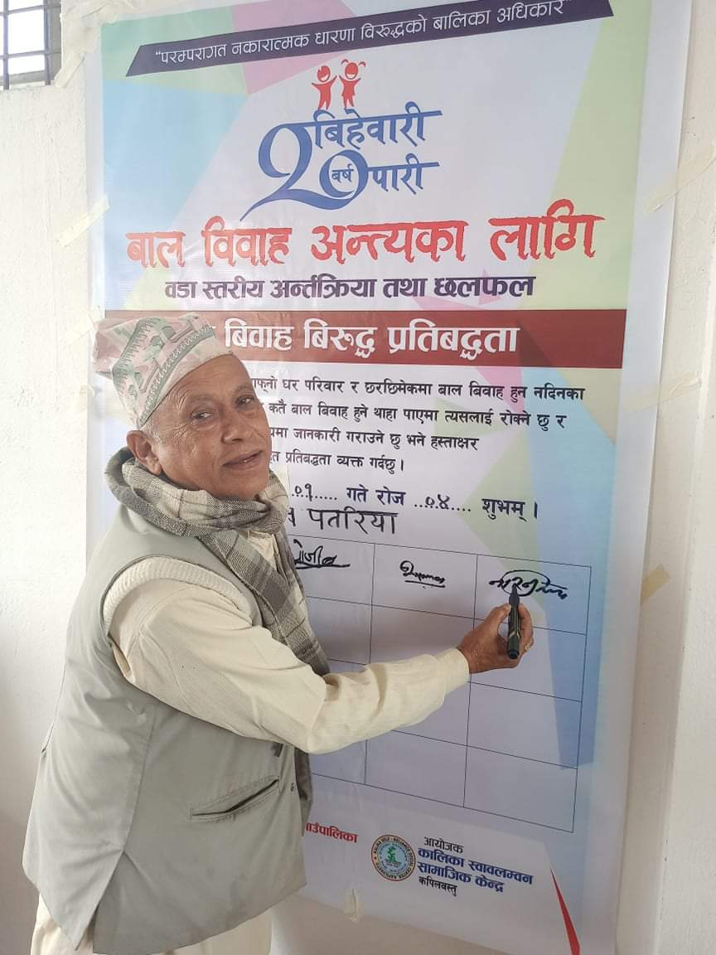
To end child marriage and dwary system we have conducted different awareness raising program on the field level which helps to deliver a message against child marriage and dwary system.
During our follow up and field visit we mate a pandit inhabitant of pateriya suddhodhan 1and he explain his experiences after the training provided by amplifier change That one couple of his community aged of 14/15 years have fallen in love from past 2 years and they have share their love with their family and both family member were agreed for marriage and invited him to conform the date of marriage. after the invitation he went there and ask with couple about their age and they told that they were 14/15 years of old and he convinced them not to marriage in this age and stop till 20 years cross but the couple and the family member were not agreed on this and the couple replied that if they will not marry recently both of them will die. after such types of replied heard by pandit, he starts thinking how to divert this marriage and start to see the date of marriage and he answered that at this time if they will get married at this age one of them will die prematurely within 1 years and have to stay separately. after all this pandit have put 2 option either they have to marry in this year and live seprate in whole life or marry after 20 years and stay happily in remaining whole life. After this the couple and family members were agree for marriage after completing of 20 years of both male and adolescent girls.
Conclusion: In this sense there have a big role of Pandit, Sokhas, maulanas and dharma gurus to stop child marriage and dwary system in the community because the community people will blindly trust them in such types of Marriage activities.

