Safe Guarding Training for GRANT Staffs and Board Member of KSSC
2020
GRANT PROJECT
KSSC
2/8/2020
An eventcompletion Report on
Safeguarding Training to staffs and Board member
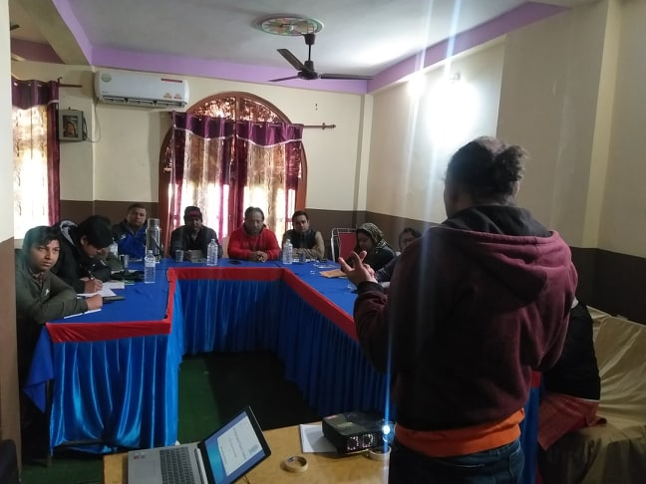
7 –8Feb, 2020

Submitted By:
Kalika Self-reliance Social Centre
Kapilvastu

I. Background
Policies and procedures are an essential component of any organization. Policies are important because they address pertinent issues, such as what constitutes acceptable behaviour by employees. And Safeguarding is one of the most which primary purpose is to provide protection – protection for organization and for its employees. Also the policy is to be complied to any member of staff or volunteer working directly with Children and Young People and Adults at risk and to any other support staff, associates who become involved in course of their work with Children, Young People and Adult at risk are informed of the policy as appropriate.
After the successful conduction of first two day program orientation, a two- day Safeguarding Training was held for the Board members and staff of Kalika Self-reliance Social Center, on children, Young People and Adults. Kalika Self-reliance Social Centre (KSSC–Nepal) recognizes its statutory and moral duty towards safeguarding children, young people and adults at risk from any form of abuse and harm whilst attending, participating in or receiving services from KSSC Nepal, community, or any other premises where its services are delivered. KSSC expects all its Staff and Associates to endorse and practice this duty at all times. KSSC has a zero tolerance approach to abuse and other harmful behavior about was discussed.

Objectives
The objectives of this event were:
- Staff and board member are informed about the Safe guarding policy.
- Board Member and GRANT staffs are capacitated to record and report in case of abuse or harm

The training was started with brainstorming as icebreaking technique. The organized training for board and staffs Member was focused on what is the safeguarding policy all about in day I. The policy was explained and followed by discussion on merits and demerits, for participatory approach participants were encouraged to actively involved in session for better understanding. Group divide and discussed into two groups for practical application of the theory concepts clarity. After the group work every group leader presented their work to the participants. Questions were asked to develop understanding and participants gave their suggestions for improvement. All the participants simulated on safe guarding tool and followed by the practical session on its application i.e how to fill the recording form, data collection, investigation and reporting system.

Major Outputs
- Kalika Self-reliance social centre staff and board members comprise 20 persons (14 male and 6 female) have learned about safeguarding.
- Safeguarding is all about ensuring that there are measures in place to make sure that beneficiaries, rights-holders and others who come into contact with KSSC are protected from all forms of abuse and harm.
- Sensitized and aware to Board and staffs that Safeguarding to children, young and adolescentsfrom abuse and harm is minimum legal responsibilities.
- It became clarity how to implement the policy

Conclusion

In the end, the Board members and staff who participated in this safeguarding training have learned about what is safeguarding and why it is important for an individual as well as organization too.

Schedule of Safeguarding training

S.N | Time | Activity | Responsible person | Remarks
Date 7 Feb 2020 (First day)
1 | 9:00-9:30 | Introduction | PM
2 | 9:30-10:15 | well come and objective sharing | ED
3 | 10:15-11:00 | Introduction anddefinition  to Policy | Prakash Dahal (Facilitator)
4 | 11:00-11:15 | Tea brake | All
5 | 11:15-12:00 | Discussion on the Scope of the policy | Prakash Dahal
6 | 12:00-01:00 | Lunch brake | All
7 | 01:00-02:00 | Discussion on the Purpose of the children, young people and adult at risk policy | Prakash Dahal
7 | 02:00-02:30 | tea brake | All
8 | 02:30-04:30 | Discussion on the definition of children, young adults | Prakash Dahal
9 | 04:30-05:00 | Review and closing of the first day | PM
Date 8 Feb 2020 (Second day)
10 | 08:00-09:00 | Brake fast | All
11 | 09:00-09:30 | First day review | PM
12 | 09:30-11:30 | Discussion about Child,  Young People and Adults abuse | Prakash Dahal
13 | 11:30-11:45 | Tea brake | All
14 | 11:45-01:15 | Discussion about the responsibilities of Senior Safe Guarding Officer and Executive Director | Prakash Dahal
15 | 01:15-02:15 | Lunch brake | All
16 | 02:15-03:00 | Discussion on the disclosure of abuse or harm. | Prakash Dahal
17 | 03:00-04:00 | Discussion on the children, Young People and Vulnerable Adults Protection Code ofConduct | Prakash Dahal
18 | 04:00-04:30 | Review and closing of the Second day | PM

Annex 1: Photograph

