Continuous Effort Made Success
Suddhodhan RM is one of the diverse backward place of Kapilvastu District. In this Municipality there are 6 wards among them Pateriya is one. The Majority of people living in this community belong to Muslim and Tharu community and the person living in this community depends on agriculture. They have given in less Priority on Health and Education so that the community people were unaware of Health related issues.
There were No any birthing centre in this village in Past so that the people living in community were bound to deliver their baby at home. Home delivery is one of the major issues of that community which leads in increase in maternal mortality and Infant mortality rate.
So that KSSC-Nepal have made interaction meeting with Municipality and Ward level and from the interaction meeting new HFOMC Guidelines was approved from the Municipality level. After the approval of New HFOMC guidelines Project have regular advocacy with HFOMC members and made interaction meeting with HFOMC members Municipality chairperson, service giver and service receiver.
On that interaction meeting one of the community members shares his experiences that he has faced a lot of difficulty at the time of delivery of her wife. Because the Health Facility haven’t provide a service on delivery. He also share that there was a problem of Transportation too to take any person to hospital if they were ill. Due to this problem there was no any option rather to deliver at home.
After he share his problem in front of HFOMC members, municipality chairperson and ward representative they have realized that there actually need to upgrade that Health facility into birthing centre and also lab services. Municipality chairperson and HFOMC members were agreed and they approved to upgrade that Health facility. And the HFOMC members and Municipality Representative have requested KSSC-Nepal to support needy Equipments for Birthing centre and Lab facility.
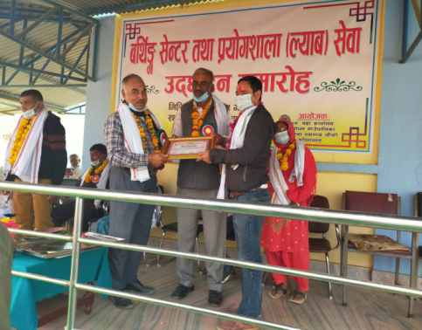
KSSC-Nepal in partnership with FAIR MED foundation Nepal have implemented Essential Health Project have also working in this areas on NTDS and MNH so KSSC/EHP have also provided the small support Pateriya Health Facility.
According to the commitment from KSSC Nepal under essential Health Project have provided all equipments but the birthing centre was not opened due to some issues in Municipality and Ward Level. After this GRANT have made regular advocacy with HFOMC members, Municipality, HF workers, Ward Level and Adolescent network to open the birthing centre. Finally this advocacy works out and the birthing centre was open and provide services from November 29 2020 (2077/8/14 B.S).
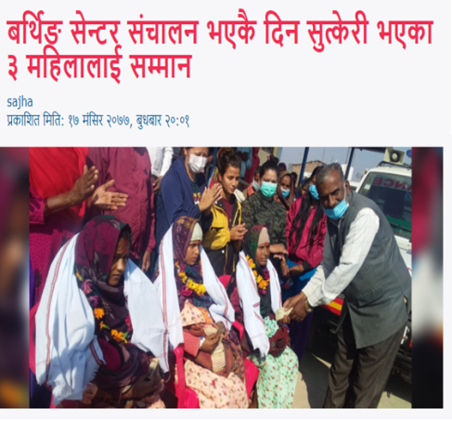
At the same date of opening of birthing centre 3 women took birth on birthing centre and the municipality have appreciated to them. Till 31 december 2020 there were 15 mothers delivered in the Birthing centre of Pateriya. The community people were so happy on opening of birthing centre and can take delivery services from their local health facility. The community people were more aware on this and take regular ANC and PNC services too from the facility.
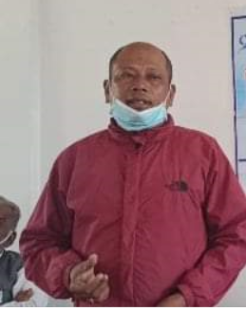
Health Post Incharge; Nathu Ram Tharu said the opening of Birthing in this area was actually like eating of iron bitten rice in past but with the help of KSSC/GRANT project on regular advocacy with municipality ward, HFOMC members and Health workers and equipments support from EHP project we made it success to open the birthing centre. So I would like to thank KSSC Family for the support and expect more support in upcoming days too.

