AFS for SRH
Suddhodhan RM is one of the diverse backward areas of Kapilvastu District. The majority of the people living in this community belong to Muslim and Tharu and the people in this community speak Awadhi language. The people living in this community give less priority on education and Health. Especially a adolescent girls didn’t allow outside except emergency work so that the girls have less knowledge on different issues what is happening outside. Mainly the adolescent girls have pass the day by doing household activities and male members goes outside for different work to join their mouth and hand.
In suddhodhan Rural Municipality the adolescent girls have less knowledge on health and have also have less educated. In this community mainly adolescent girls were feel shame to visit health facility and share their problems in family and in Health facility too.
KSSC under GRANT project have reform the adolescent group and starts counseling and also provide training on health issue related topics (SRHR, AFS corner) and their rights which was provided by Municipality as well as Health facility. Project also regular advocate with municipality ward, health facility, HFOMC members and Adolescent girls about the problem of the community and to establish AFS corners which helps adolescent girls to share their problems without any hindrance.
Furthermore Project has made a one day workshop with HFOMC members on adolescent problems and importance of Adolescent friendly corners. After the workshop we project team and HFOMC members including Health works made a action plan to develop AFS corners. After the action plan we jointly list out the equipments needed to establish AFS corner. After the plan they have requested KSSC/GRANT program to support needy equipments to develop AFS corner.
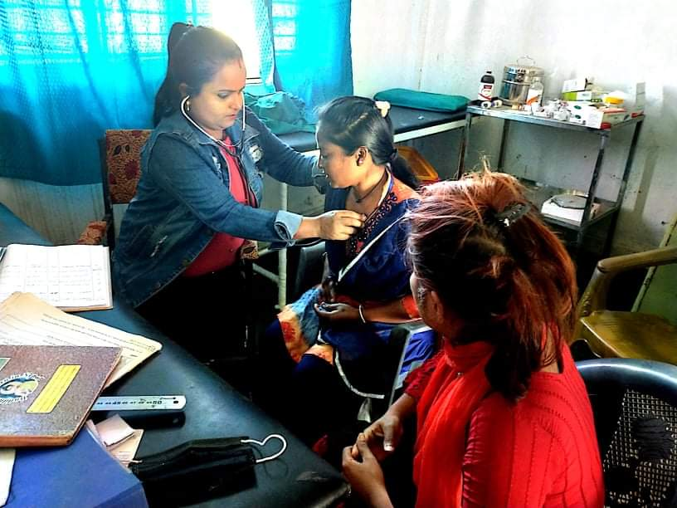
After all this KSSC have made a field survey for the development of AFS corner and finally GRANT project have committed to provide needy items and the remaining will be managed by Health facility, Municipality, HFOMC and ward. After the regular advocacy with health facility and HFOMC members Health facility have started AFS corners in a separate room and start their services. Till date 6 adolescent girls took services from the facility and the health facility has put record separately who comes to take services in the facility. These types of services will help to share their problems without hindrance.
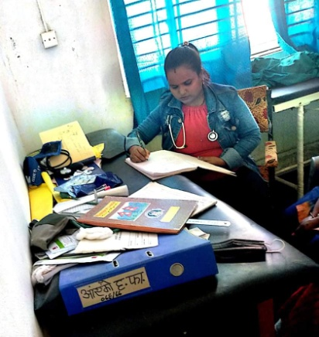
Labani Birthing centre In-charge Sima Jayswal said that these types of services in the health facility actually help to share the problem and council adolescent girls on SRHR. She also added that in past girls conceal their problems but after the establishment of AFS corner adolescent girls who visited to take services feel secure and share all health problems nowadays. Least but not last she thank to KSSC family for the full support to uplift the knowledge and skills on ASRHR of adolescent girls.

